
Mobile Media Development
Dr. Cindy Royal
Texas State University
School of Journalism and Mass Communication

Passing Information Using TextFields, Switches and Sliders
Exercise: You have had experience with all these topics. Now you will assemble them into an app with multiple view controllers and pass the values back to the initial VC (view controller). Follow these steps carefully to set up this app.

Remember, as you go through this exercise, if you have to remove or delete anything, make sure to remove any connections via the Connections Inspector.

- Start with a new project. Single View app. Name it MultipleEx.

- Create an application that has two additional View Controllers. Drag them to the Storyboard and create and attach View Controllers for each one (File, New, File, Cocoa Touch Class). You can name them SwitchViewController and SliderViewController. Make sure the subclass is UIViewController. You connect these to the views in the Storyboard by clicking the View Controller button and selecting the correct controller in the Identity Inspector. Make sure the main storyboard is the Initial View Controller.

- Create a label that indicates the name of each scene as Name, Switch and Slider, just to indicate those scenes near the top. Center horizontally using the Align tool and make them bold with the Attribute Inspector

- In the initial View Controller, create buttons to go to the Switch and Slider VCs. Include them on the top right, but far down enough so they won’t be covered by the Navigation Controller when you add it. You can connect these with a segue (ctrl drag to the scene from each button, choose Show).
- In the initial View Controller, Embed a Navigation Controller (Editor, Embed In, Navigation Controller). This will provide the navigation for a Back button. Make sure you are in the main storyboard and that it is set to Initial View Controller before you Embed the Navigation Controller.
- On the initial View Controller, include a TextField that asks for Name. Add a Button to the storyboard below the Text Field to submit the name. Have it with text “Submit”.
- Also include labels as Outlets for Name, Switch and Slider in the initial view controller.
- In the Switch view controller, include Switch from the Library. In the Identity Inspector, have it initially set to “Off.”
- Include a label that on the Switch scene will be used to show you the value of the Switch as it changes.
- In the Slider view controller, include a Slider from the Library. In the Identity Inspector, use 1-5, having it start at 1.
- Include a label on the Slider scene that will be used to show you the value of the Slider as it changes.

See image below for general layout of each View in the Storyboard. But feel free to design each View the way you want and use the alignment tools we discussed where applicable.

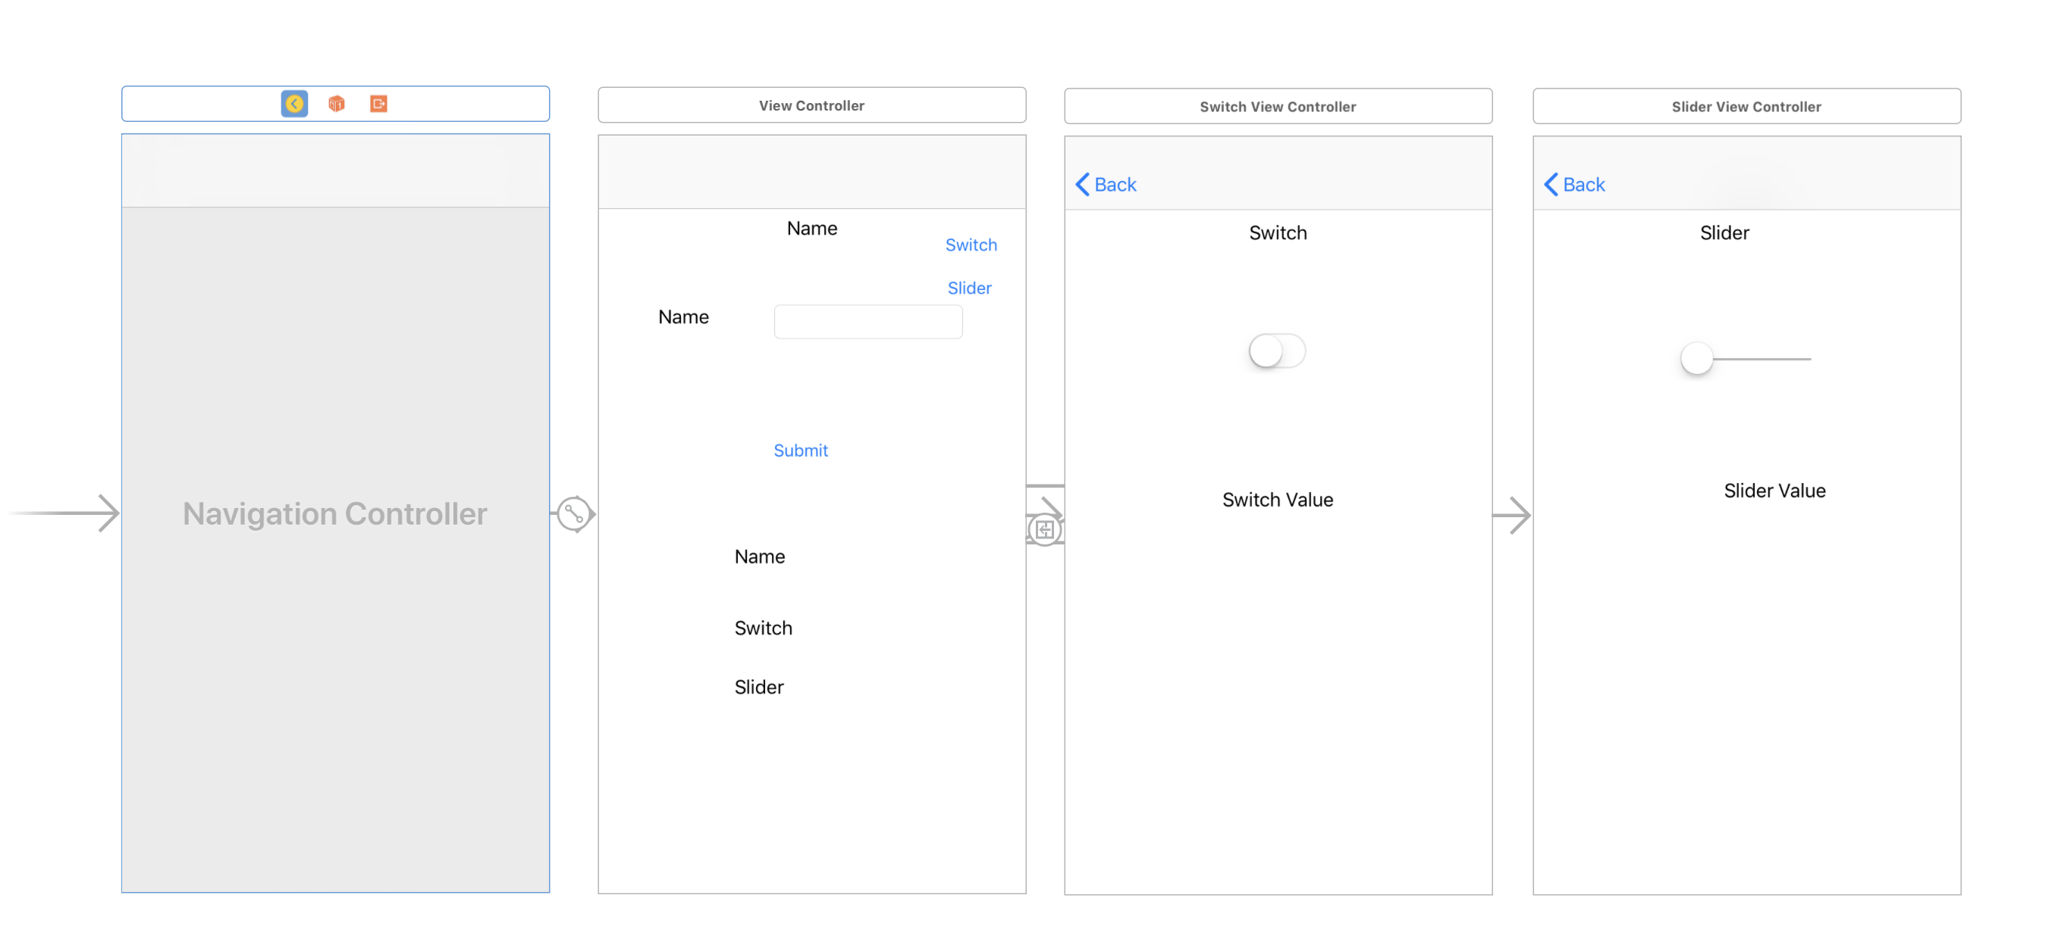

At this point, you can test that your app navigates properly, back and forth between each scene. We will add the functionality next.

Initial View Controller
Now get the functionality for one view controller at a time.
- Initialize in the main VC below the import UIKIt statement (but above the class ViewController declaration):

class Global {
var nameVar = String()
var switchVar = String()
var sliderVar:Int = 0
}

let global = Global()

- In the main view controller code, connect each of the three labels at the bottom to the code as Outlets named theName, theSwitch and theSlider respectively (ctrl drag). Make sure to drag the label to a size that will be able to show the result.

- Connect the TextField to the code as an Outlet named myName.
- Connect the Submit button to the code as an Action named myButton and include this code in it.
global.name = myName.text!
theName.text = "Name: " + global.nameVar
myName.resignFirstResponder()

Remember that we used resignFirstResponder() to make the keyboard go away after submitting the text field. Test the app and fill out the TextField and Submit. You should see the value changing in the Name label below.

Switch View Controller

- Make sure your SwitchViewController is connected in the Storyboard (ViewController button at top of scene, make sure SwitchViewController is selected in the Identity Inspector). Use option-click to open the SwitchViewController code.

- Connect the label in that view controller to the code as an Outlet named switchVal. This will show you the value of your switch as you test it in that view.

- Connect the Switch to the code. Make it an Action, type UISwitch (very important). Name it mySwitch. Put this in the code for that function:

if sender.isOn {
global.switchVar = "on"
}
else {
global.switchVar = "off"
}
switchVal.text = global.switchVar

- In the viewDidLoad function, include this to initialize the original state of the switch as “off,” so that every time you go back to this scene, the value of the Switch is in sync with the switch itself (which we told to start at “off”)

global.switchVar = "off"

- Go back to the main view controller and storyboard (option-click on the view controller to open the code). Create this function. This will include what we want to appear when the user returns to the main view controller using the Back button.

override func viewWillAppear(_ animated: Bool){
theSwitch.text = "Switch: \(global.switchVar)"
}

You should be able to run the app and see the correct results now for Name and Switch on the initial view controller when you return to it.

Slider View Controller

- Make sure your SliderViewController is connected in the Storyboard (ViewController button at top of scene, make sure SliderViewController is selected in the Identity Inspector). Use option-click to open the SliderViewController code.

- Connect the label in that view contoller to the code as an Outlet named sliderVal. This will show you the value of your slider as you test it in that view.

- Connect the Slider to the code. Make it an Action, type UISlider. Name it mySlider. Put this in the code for that function:

global.sliderVar = Int(sender.value)
sliderVal.text = "\(global.sliderVar)"

- Back in the main view controller add this code to the viewWillAppear function that you created above.

theSlider.text = "Slider: \(global.sliderVar)"

You should be able to run the app and see the correct results now for Name, Switch and Slider appear on the main storyboard after you visit the respective pages. If you have any errors, troubleshoot them, remove problem code or items and try again.

Congrats on finishing the exercise!

Submit the Completed Exercise
When you are finished, go to GitHub.com (use Chrome). Make a repository on your account called MultipleEx and place the files for the XCode project in it. Then in the #mobileex channel, include the link to this repository.

Think about how you will use all these features in your final project!

